This document outlines step by step instructions to subscribe to HOBL release notes, updates, and notifications. All changes/updates to HOBL will be emailed to the provided email address.

- Navigate to Azure ADO browser User Settings Notifications
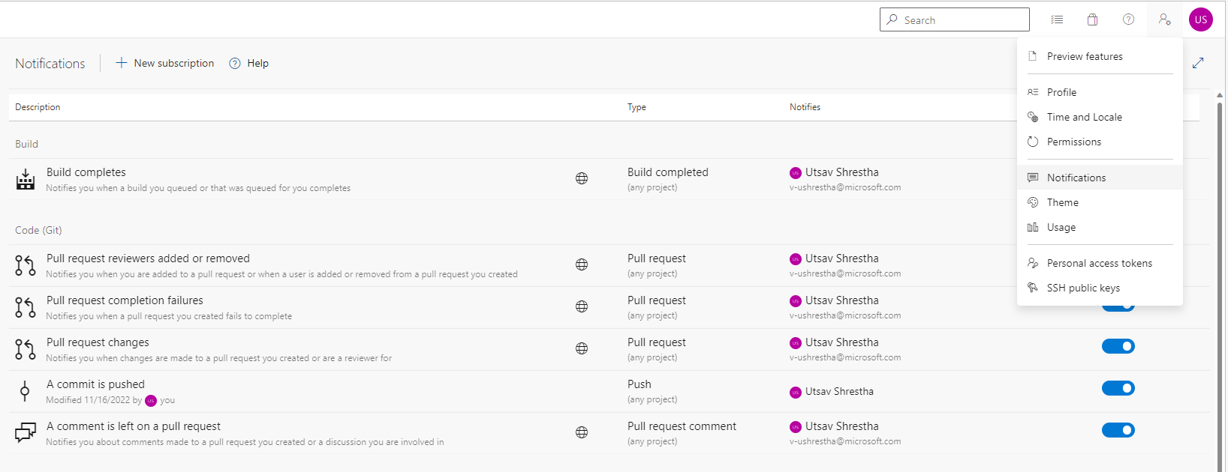
- Select New subscription as shown below
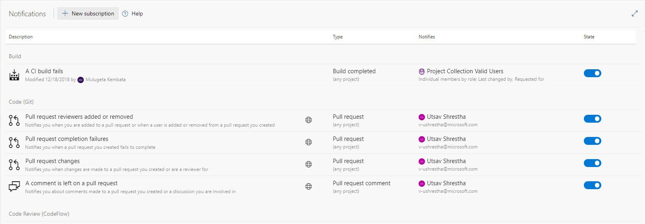

- Select Code (Git) A Commit is pushed Next
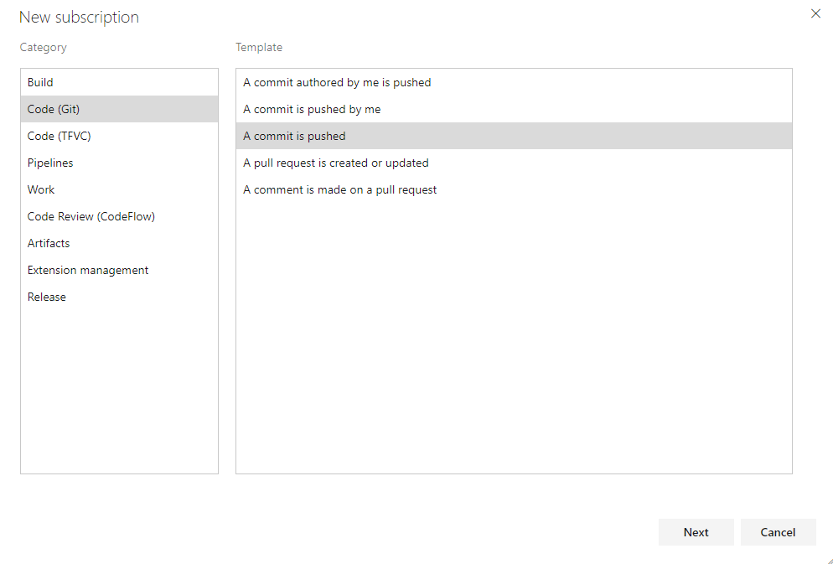
- Update criteria for Field/Operator/Value as shown below and save.
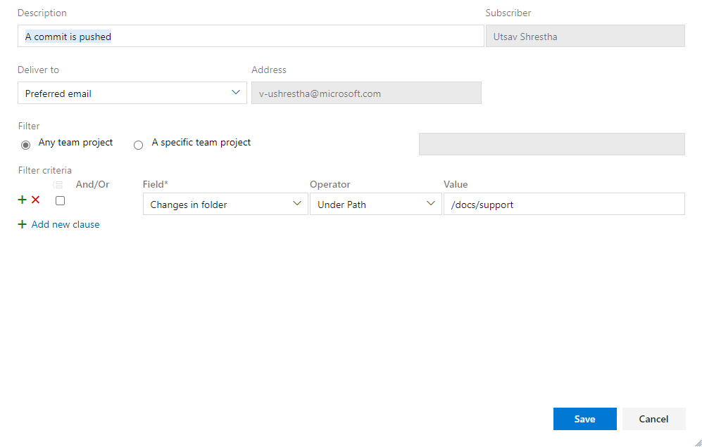
- Updates and release notes will be emailed to the subscribed user.
